EXP NO: 30
ANALYSIS OF CELLULAR FREQUENCY PLANNING AND HANDOVER PERFORMANCE UNDER USER MOBILITY CONDITIONS USING MATLAB

Objectives:
- To understand the basic concept of cellular frequency planning and frequency reuse.
- To determine a suitable cellular cluster size and frequency-reuse factor for a simplified hexagonal cellular layout.
- To assign channel/frequency groups to cells and visualize the resulting reuse pattern.
- To model a mobile user moving through adjacent cells and calculate the received signal strength from serving and neighboring base stations. To identify handover conditions using a received-signal-strength comparison with a handover threshold and hysteresis margin.
- To measure and analyze handover locations, number of handovers, outage regions, and signal strength variation under user mobility.

Procedure:
1. Open the MATLAB software and create a new script file.
2. Clear the command window, workspace, and close all previously opened figure windows.
3. Define the positions of the cellular base stations.
4. Define the user movement along the cellular coverage area.
5. Determine the serving cell for each user position based on the nearest base station.
6. Record the cell association corresponding to each user location.
7. Display the user position and connected cell information.
8. Plot the handover performance showing the variation of connected cells with user movement.
9. Plot the cellular frequency planning indicating the locations of the base stations.
10. Execute the MATLAB program.
11. Observe the user mobility, connected cell transitions, and handover points.
12. Analyze the effectiveness of frequency planning and handover performance.

PROGRAM :
clc;
clear;
close all;
% Cell Centers (3 Cells)
cellPos = [0 500 1000];
% User Movement
user = 0:10:1000;
% Nearest Cell Selection (Handover)
handover = zeros(size(user));
for i = 1:length(user)
[~,handover(i)] = min(abs(user(i)-cellPos));
end
% Display
disp('User Position Connected Cell')
disp([user' handover'])
% Plot
figure;
subplot(2,1,1)
plot(user,handover,'b','LineWidth',2)
title('Handover Performance')
xlabel('User Position (m)')
ylabel('Cell Number')
grid on
subplot(2,1,2)
stem(cellPos,[1 2 3],'filled')
hold on
plot(user,ones(size(user))*2,'r--')
title('Cellular Frequency Planning')
xlabel('Distance (m)')
ylabel('Cell')
grid on

Output:
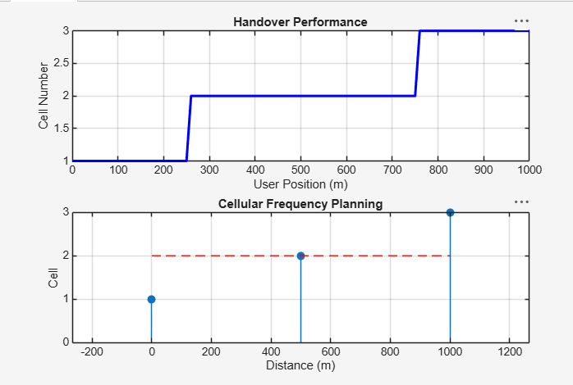
Result:
- The cellular frequency planning and handover process were successfully simulated in MATLAB, and the serving cell was identified for different user locations.
- +

- The simulation demonstrated successful handovers as the user moved across adjacent cells, validating the effectiveness of cellular frequency planning under user mobility conditions.

